FISH 558: Example Application III (Use of the SIR Algorithm)

The Eastern North Pacific stock of gray whales, Eschrichtius robustus, has been monitored using visual counts since 1967/68 at Granite Canyon, California (Fig. 1). There was been considerable debate regarding whether this population is approaching (and has perhaps even reached) its environmental carrying capacity. Methods based on examining the 2nd derivative of the count data were developed to detect a reduction in growth rate (e.g. Boveng et al., 1988; Gerrodette, 1988; Goodman, 1988), but these methods are now considered flawed (Butterworth et al., 2002).

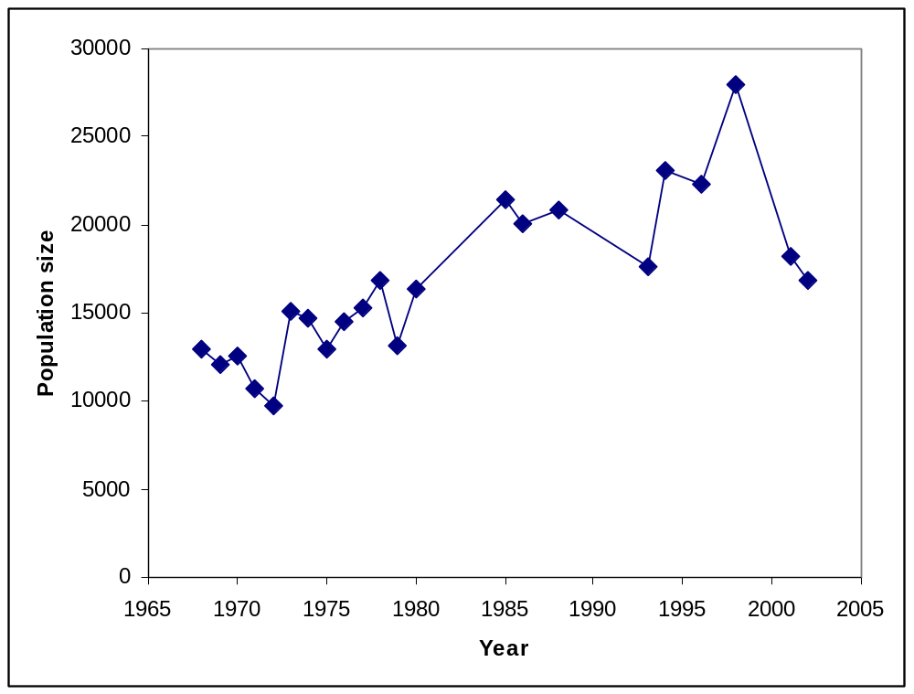
Figure 1. Counts of gray whales (1967/68-2001/02).

An alternative approach to addressing this problem is to compare models with and without density-dependence. The simplest such models are the exponential and logistic models, i.e.:
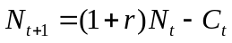 (1a)
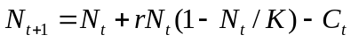 (1b)
where 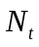 is the number of animals at the start of year t (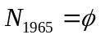),
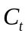 is the catch during year t,
r is the intrinsic growth rate, and
K is the environmental carrying capacity.
The contribution of the abundance data to the likelihood function is based on the assumption that the estimates of abundance are log-normally distributed about their expected values, i.e.:
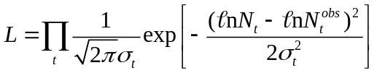 (2)
where 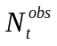 is the estimate of abundance for year t,
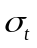 is the assumed coefficient of variation of , i.e.:
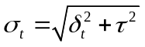 (3)
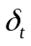 is the observed (sampling) coefficient of variation of, and
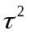 is the additional variance (additional variation needs to be modeled because it is well-known that the sampling coefficients of variation for the eastern North Pacific gray whales under-estimate the true extent of variation).
Tasks
- Use the SIR algorithm to calculate a Bayes factor to compare the logistic and exponential models. Use the prior distributions listed in Table 1. The abundance estimates and catches needed to implement the models are included in the spreadsheet Ex3a.csv and Ex3b.csv.
- Some scientists believe that the only real evidence for density-dependence for the Eastern North Pacific gray whales are the last two data points in the time-series (those for 2000/01 and 2001/02). Check this assertion by repeating task A leaving out the last two data points.
- The question whether the population is close to its carrying capacity can be assessed by calculating the probability that the population size exceeds 90% of carrying capacity. Use the analysis based on the logistic model to calculate this probability.

Hint: Write a function which takes the data and computes the projected abundance and use the function I provide which calculates the negative log-likelihood. You also need to write a function which samples parameter vectors from the posterior distribution.
References
Boveng, P., DeMaster, D.P. and B.S. Stewart. 1988. Dynamic response analysis. III. A consistence filter and application to four northern elephant seal colonies. Mar. Mammal. Sci. 4:210-222.
Butterworth, D.S., Borchers, D.L. and A.E. Punt. 2002. Dynamic response analysis for the eastern North Pacific gray whale population: an alternative approach. J. Cetacean Res. Manage. 4:77-83.
Gerrodette, T. 1988. Dynamic response analysis. II. Evaluation of dynamic response analysis in a simulated no-harvest case. Mar. Mammal. Sci. 4:196-209.
Goodman, D. 1988. Dynamic response analysis. I. Quantitative determination of optimum sustainable production level. Mar. Mammal. Sci. 4:183-195.

Table 1. The prior distributions.

Parameter | Prior distribution
Carrying capacity, K | U[20,000; 50,000]
Intrinsic growth rate, | U[0; 0.15]
1965 population size, | U[10,000; 15,000]
Additional SD, | U[0.1; 0.2]

